|  |
| --- |
| College LaSalle |
| Project - Oriented Object Programming User and Technical Manual |
|  |
| Presented to: Mihai Maftei. |

Your name: Christian Denis Marcelin

07/17/2023

Version 1.0

Start by adding a short description of your project, and the languages (technologies) used:

⦁ Language: C#

⦁ Used tool(s): Visual Studio version 2022

**Present the print screens of yours forms, and have a detailed description of the functionalities (step by step).**

⦁ If you click on the Exit button, the application exits

⦁ if you click on the convert from button, One currency is chosen from the from group and It is converted to the to category.

* ⦁￼If you click on either Temperature conversion or Money Conversion you get to the appropriate Converter screen

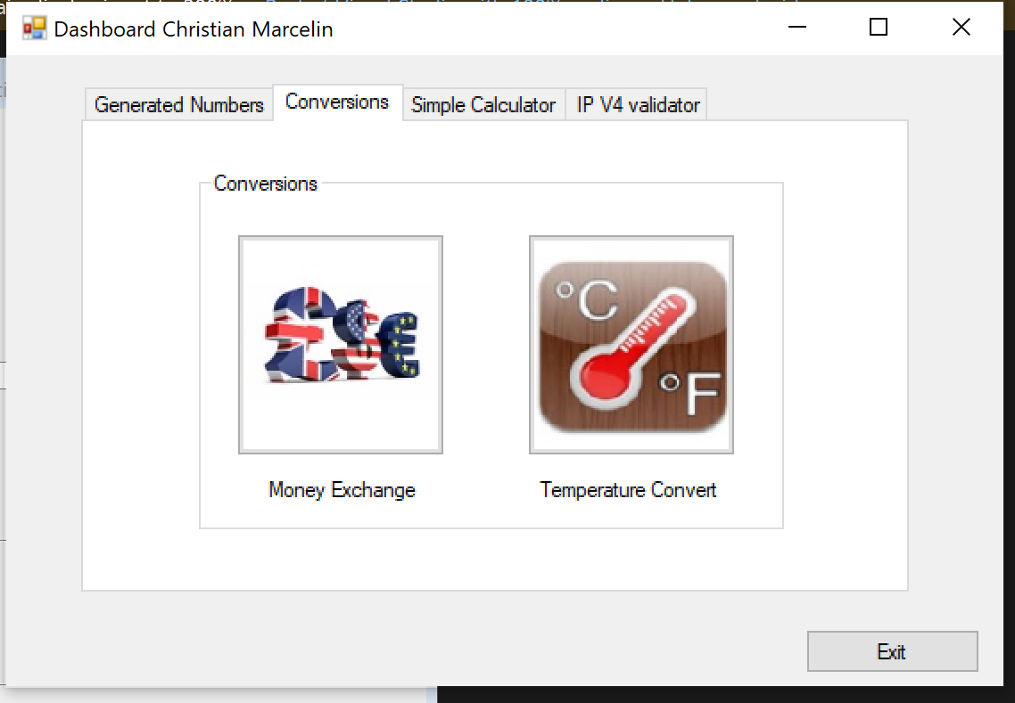

-

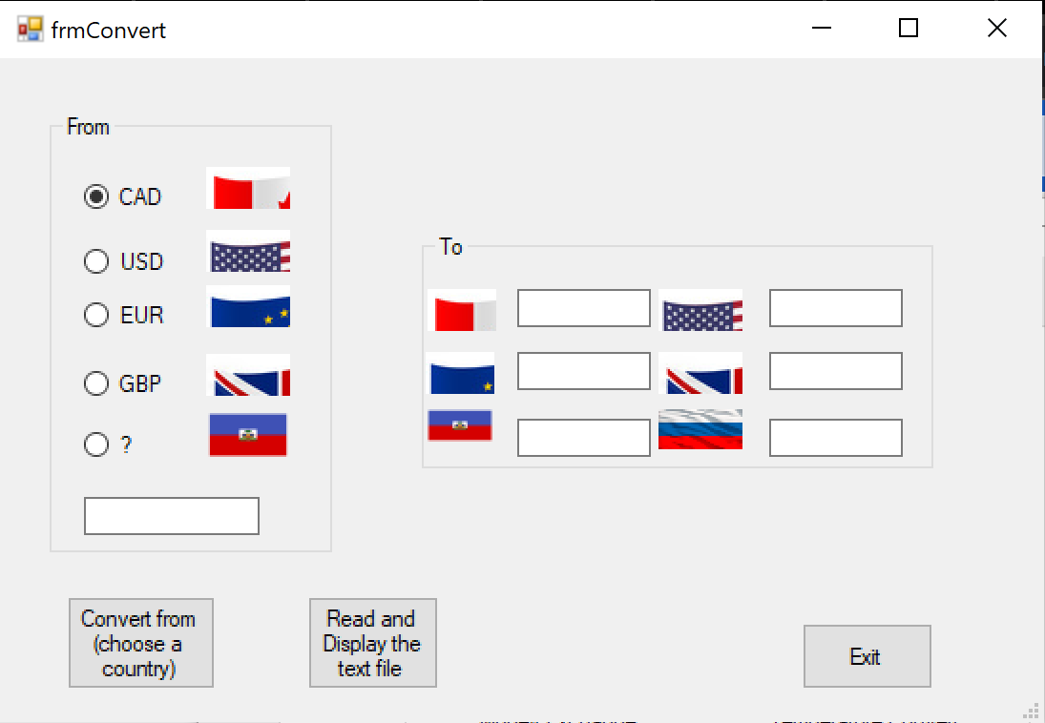

-You can choose your appropriate from and to currency and see the conversion

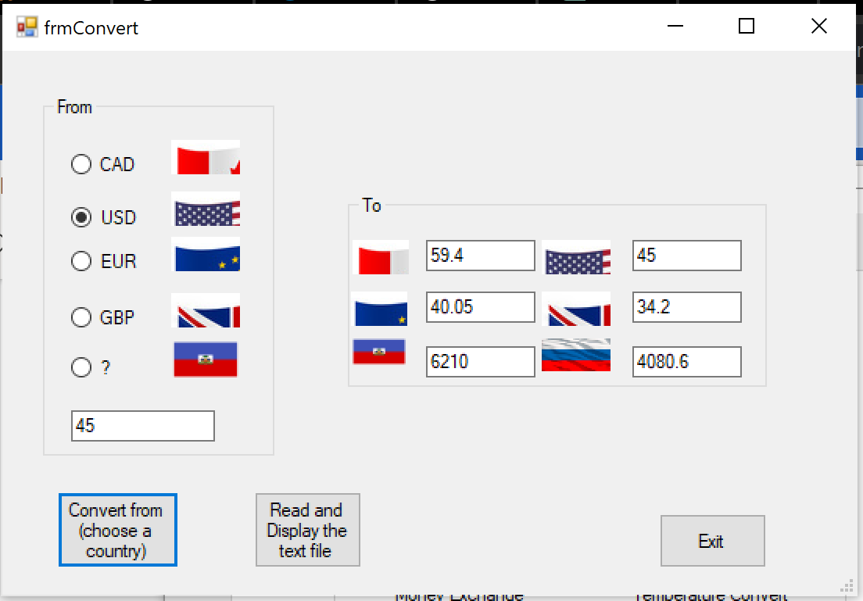

-You can input Celcius and Farenheit conversion and get the conversion.

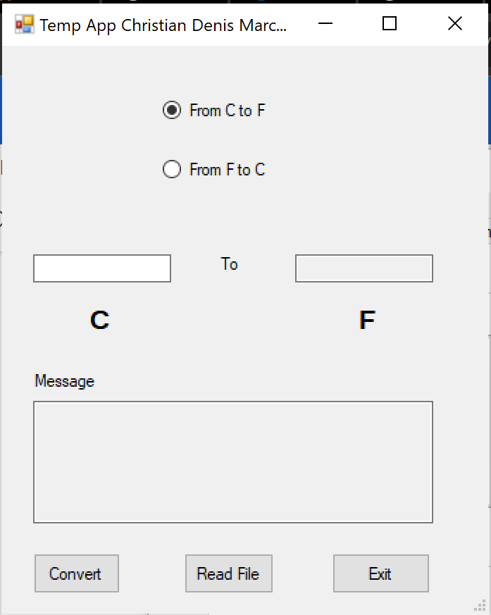

⦁ Present the code of your application (forms).

LotoMAX

… your code goes here

Loto649

… your code goes here

IPv4

… your code goes here

TempConverter

//Christian Denis Marcelin

//V2.0

using System;

using System.Collections.Generic;

using System.ComponentModel;

using System.Data;

using System.Drawing;

using System.IO;

using System.Linq;

using System.Text;

using System.Threading.Tasks;

using System.Windows.Forms;

using static System.Windows.Forms.VisualStyles.VisualStyleElement;

namespace WindowsFormsApp7

{

public partial class frmConvertTemp : Form

{

public frmConvertTemp()

{

InitializeComponent();

}

public static string GetTemperatureDescription(double celsius, double fahrenheit)

{

if (celsius == 100 || fahrenheit == 212)

{

return "Water boils";

}

else if (celsius == 40 || fahrenheit == 104)

{

return "Hot Bath";

}

else if (celsius == 37 || fahrenheit == 98.6)

{

return "Body temperature";

}

else if (celsius == 30 || fahrenheit == 86)

{

return "Beach weather";

}

else if (celsius == 21 || fahrenheit == 70)

{

return "Room temperature";

}

else if (celsius == 10 || fahrenheit == 50)

{

return "Cool Day";

}

else if (celsius == 0 || fahrenheit == 32)

{

return "Freezing point of water";

}

else if (celsius == -18 || fahrenheit == 0)

{

return "Very Cold Day";

}

else if (celsius == -40 || fahrenheit == -40)

{

return "Extremely Cold Day";

}

else

{

return "No specific description available";

}

}

private void button1_Click(object sender, EventArgs e)

{

FileStream fs = new FileStream(@"./TempConversions.txt", FileMode.Append, FileAccess.Write);

// create the output stream for a text file that exists

StreamWriter textOut = new StreamWriter(fs);

// write the fields into text file

DateTime currentDate = DateTime.Now.Date;

//textOut.WriteLine(textBox1.Text);

// close the output stream for the text file

if (radioButton1.Checked)

{

// Convert Celsius to Fahrenheit

if (double.TryParse(textBox1.Text, out double celsius))

{

double fahrenheit = (celsius * 9 / 5) + 32;

String Message = GetTemperatureDescription(celsius, fahrenheit);

textBox2.Text = fahrenheit.ToString();

textOut.Write($"{textBox1.Text} C = {textBox2.Text}F {currentDate} {Message}" + "\n");

textBox3.Text = Message;

}

else

{

// Invalid input for Celsius

MessageBox.Show("Invalid Input");

}

}

else if (radioButton2.Checked)

{

// Convert Fahrenheit to Celsius

if (double.TryParse(textBox1.Text, out double fahrenheit))

{

double celsius = (fahrenheit - 32) * 5 / 9;

String Message = GetTemperatureDescription(celsius, fahrenheit);

textBox2.Text = celsius.ToString();

textOut.Write($"{textBox1.Text} F = {textBox2.Text}C {currentDate} {Message}" + "\n");

textBox3.Text = Message;

}

else

{

// Invalid input for Fahrenheit

MessageBox.Show("Invalid Input");

}

}

textOut.Close();

}

private void button2_Click(object sender, EventArgs e)

{

FileStream fs = new FileStream(@"./TempConversions.txt", FileMode.Open, FileAccess.Read);

try

{

// create the object for the input stream for a text file

StreamReader textIn = new StreamReader(fs);

string textToPrint = "";

// read the data from the file and store it in the list

while (textIn.Peek() != -1)

{

string row = textIn.ReadLine();

// string[] columns = row.Split('|');

textToPrint += row + "\n";

}

MessageBox.Show(textToPrint);

// close the input stream for the text file

textIn.Close();

}

catch (FileNotFoundException)

{

MessageBox.Show(@".../LottoNbrs.txt" + " not found.", "File Not Found");

}

catch (DirectoryNotFoundException)

{

MessageBox.Show(@".../LottoNbrs.txt" + " not found.", "Directory Not Found");

}

catch (IOException ex)

{ MessageBox.Show(ex.Message, "IOException"); }

finally

{ if (fs != null) fs.Close(); }

}

private void button3_Click(object sender, EventArgs e)

{

if (MessageBox.Show("You want to Exit?", "Exit", MessageBoxButtons.YesNo).ToString() == "Yes")

{

this.Close();

}

}

private void radioButton1_CheckedChanged(object sender, EventArgs e)

{

label4.Text = "C";

label3.Text = "F";

}

private void radioButton2_CheckedChanged(object sender, EventArgs e)

{

label4.Text = "F";

label3.Text = "C";

}

}

}

Money Converter

using System;

using System.Collections.Generic;

using System.ComponentModel;

using System.Data;

using System.Drawing;

using System.IO;

using System.Linq;

using System.Text;

using System.Threading.Tasks;

using System.Windows.Forms;

namespace WindowsFormsApp7

{

public partial class frmConvert : Form

{

DateTime startTime = DateTime.Now;

public frmConvert()

{

InitializeComponent();

}

private void button1_Click(object sender, EventArgs e)

{

FileStream fs = new FileStream(@"./MoneyConversions.txt", FileMode.Append, FileAccess.Write);

// create the output stream for a text file that exists

StreamWriter textOut = new StreamWriter(fs);

// write the fields into text file

DateTime currentDate = DateTime.Now.Date;

//textOut.WriteLine(textBox1.Text);

// close the output stream for the text file

if (radioButton1.Checked)

{

textBox1.Text = textBox6.Text;

textBox2.Text = (Convert.ToDouble(textBox6.Text)* 0.757).ToString() ;

textBox3.Text = (Convert.ToDouble(textBox6.Text) * 0.674).ToString();

textBox4.Text = (Convert.ToDouble(textBox6.Text) * 0.58).ToString();

textBox5.Text = (Convert.ToDouble(textBox6.Text) * 104).ToString();

textBox7.Text = (Convert.ToDouble(textBox6.Text) * 68.83).ToString();

textOut.Write($"{currentDate} {textBox1.Text} = {textBox1.Text} CAD; {textBox2.Text}USD; {textBox3.Text}EUR; {textBox4.Text}GBP; {textBox5.Text}HTG ; {textBox7.Text} RUB" + "\n");

}

else if (radioButton2.Checked)

{

textBox2.Text = textBox6.Text;

textBox1.Text = (Convert.ToDouble(textBox6.Text) * 1.32).ToString();

textBox3.Text = (Convert.ToDouble(textBox6.Text) * 0.89).ToString();

textBox4.Text = (Convert.ToDouble(textBox6.Text) * 0.76).ToString();

textBox5.Text = (Convert.ToDouble(textBox6.Text) * 138).ToString();

textBox7.Text = (Convert.ToDouble(textBox6.Text) * 90.68).ToString();

textOut.Write($"{currentDate} {textBox2.Text} = {textBox1.Text} CAD; {textBox2.Text}USD; {textBox3.Text}EUR; {textBox4.Text}GBP; {textBox5.Text}HTG ; {textBox7.Text} RUB" + "\n");

}

else if (radioButton3.Checked)

{

textBox3.Text = textBox6.Text;

textBox1.Text = (Convert.ToDouble(textBox6.Text) * 1.5).ToString();

textBox2.Text = (Convert.ToDouble(textBox6.Text) * 1.12).ToString();

textBox4.Text = (Convert.ToDouble(textBox6.Text) * 0.86).ToString();

textBox5.Text = (Convert.ToDouble(textBox6.Text) * 156).ToString();

textBox7.Text = (Convert.ToDouble(textBox6.Text) * 101).ToString();

textOut.Write($"{currentDate} {textBox3.Text} = {textBox1.Text} CAD; {textBox2.Text}USD; {textBox3.Text}EUR; {textBox4.Text}GBP; {textBox5.Text}HTG ; {textBox7.Text} RUB" + "\n");

}

else if (radioButton4.Checked)

{

textBox4.Text = textBox6.Text;

textBox1.Text = (Convert.ToDouble(textBox6.Text) * 1.72).ToString();

textBox3.Text = (Convert.ToDouble(textBox6.Text) * 1.31).ToString();

textBox2.Text = (Convert.ToDouble(textBox6.Text) * 1.16).ToString();

textBox5.Text = (Convert.ToDouble(textBox6.Text) * 181).ToString();

textBox7.Text = (Convert.ToDouble(textBox6.Text) * 118).ToString();

textOut.Write($"{currentDate} {textBox4.Text} = {textBox1.Text} CAD; {textBox2.Text}USD; {textBox3.Text}EUR; {textBox4.Text}GBP; {textBox5.Text}HTG ; {textBox7.Text}RUB" + "\n");

}

else

{

textBox5.Text = textBox6.Text;

textBox1.Text = (Convert.ToDouble(textBox6.Text) * 0.0095).ToString();

textBox3.Text = (Convert.ToDouble(textBox6.Text) * 0.0072).ToString();

textBox2.Text = (Convert.ToDouble(textBox6.Text) * 0.0064).ToString();

textBox4.Text = (Convert.ToDouble(textBox6.Text) * 0.0065).ToString();

textBox7.Text = (Convert.ToDouble(textBox6.Text) * 0.65).ToString();

textOut.Write($"{currentDate} {textBox5.Text} = {textBox1.Text} CAD; {textBox2.Text}USD; {textBox3.Text}EUR; {textBox4.Text}GBP; {textBox5.Text}HTG ; {textBox7.Text}RUB" + "\n");

}

textOut.Close();

}

private void button2_Click(object sender, EventArgs e)

{

FileStream fs = new FileStream(@"./MoneyConversions.txt", FileMode.Open, FileAccess.Read);

try

{

// create the object for the input stream for a text file

StreamReader textIn = new StreamReader(fs);

string textToPrint = "";

// read the data from the file and store it in the list

while (textIn.Peek() != -1)

{

string row = textIn.ReadLine();

// string[] columns = row.Split('|');

textToPrint += row + "\n";

}

MessageBox.Show(textToPrint);

// close the input stream for the text file

textIn.Close();

}

catch (FileNotFoundException)

{

MessageBox.Show(@".../LottoNbrs.txt" + " not found.", "File Not Found");

}

catch (DirectoryNotFoundException)

{

MessageBox.Show(@".../LottoNbrs.txt" + " not found.", "Directory Not Found");

}

catch (IOException ex)

{ MessageBox.Show(ex.Message, "IOException"); }

finally

{ if (fs != null) fs.Close(); }

}

private void button3_Click(object sender, EventArgs e)

{

int minutes = (int)(startTime - DateTime.Now).TotalMinutes;

int seconds = (int)(startTime - DateTime.Now).TotalSeconds;

if (MessageBox.Show($"Do you want to quit this app? You have been here for {minutes} minutes and {seconds} seconds ", "Exit", MessageBoxButtons.YesNo).ToString() == "Yes")

{

this.Close();

}

}

}

}

⦁ Present the classes and/or methods that you create or you did use in the project.

Class/Method Name Description

⦁ FileStream To open the file and perform operation

⦁ StreamWriter To Write to the file

⦁ DateTime A time object to get the current time

⦁ **Present the difficulties that you have, what was the hardest and the easiest part of your project.**

The main difficulty I had in this project getting the picture for the countries to show up properly.